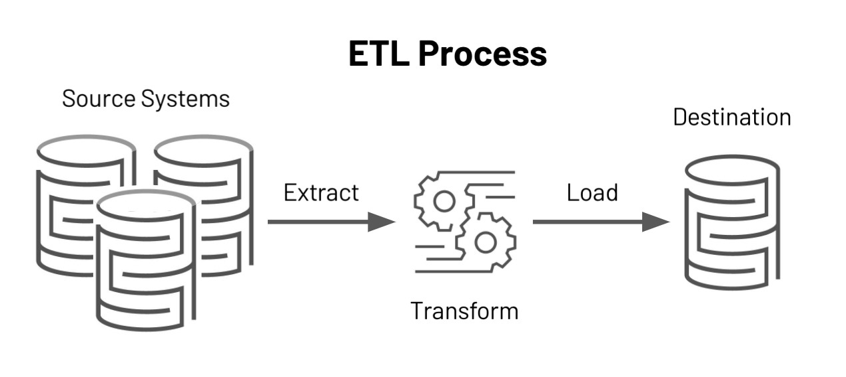

Use Case :

* We are going to built a simple and commonly used domain and we can call it customer sales.In that domain,we have customer data set and item data set all the purchases and transaction made are recorded into n order data set.
* We are implementing ETL work flow.
* We gather the data three dataset from client end.
* Customer data
* Order data
* Salesman data

Phases of Project:

This is the project divided into two phases

Phase 1:

History loading or full loading or row loading.

OR

Phase 2:

Incremental loading.